Double refraction addition to dual axis laser model

Owen Lu

Electroimpact Inc.

owenl@electroimpact.com

*Abstract*—This document details the calculations that were done to generate rays passing through refractive elements. Refractive elements manifest themselves as an offset transformation on the initial laser ray. This offset however does dependent on the angle of incidence.

# Introduction

Previously, laser ray calculations have neglected the effects of a glass piece at the output of the projector. However, some data characteristics were unable to be resolved neglecting this element. Thus, an investigation on the effects of refraction on the laser accuracy will be done. The main parameter being studied is the thickness on the signal error.

# Law of refraction

The law of refraction, commonly known as Snell’s law allows the calculation of refracted angles knowing the refractive index of both media. The knowing $θ_{1}$ and the indices of refraction $θ_{2}$ can be calculated via (1).

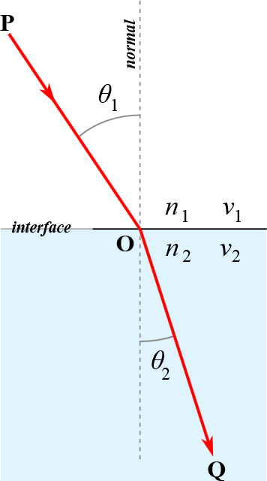

Figure - Diagram illustrating refraction effects on ray

|  |  |  |
| --- | --- | --- |
|  |  | () |

# Assumptions

In the specific system, two refractions are assumed to take place as the laser ray exits the enclosure. The ray is assumed to be in air and then is refracted through glass, and subsequently refracted into air. In this process the output ray is parallel and offset from the original, with the offset depending on the material thickness.

Although between two parallel lines, there are infinite offsets that can map a point on one line to the other, the specific offset used will be the refraction vector itself that is the ray path within the second medium.

We assume that the normal and the ray input from an acute angle. Thus, in the case of Figure 1 the normal of the blue medium would be pointed downwards.

$$θ_{1}=\operatorname{acos}\left(r_{1}⋅n\right)$$

# Acute normal case

Since any plane has a valid definition for 2 different normal vectors, we must consider each case for verify the validity of the refraction formulas. The approach is to derive valid equations for one case, and develop a condition which can be used to reduce the problem into the pre-solved case.

Using the acute angle assumption we assume $θ_{1}$ can be calculated.

$$θ_{1}=\operatorname{acos}\left(r_{1}⋅n\right)$$

Using Eq. 1 we can calculate the refraction angle.

$$θ_{t}=\operatorname{asin}\left(\frac{n_{1}}{n_{2}}\sin\left(θ_{1}\right)\right)$$

To generate a rotation equation we use a vector angle representation of rotation.

$$α=θ_{1}-θ_{t}$$

$$u=\frac{r_{1}×n}{\left|r_{1}×n\right|}=\left[u_{x},u_{y},u_{z}\right]'$$

$$q=\left[\cos\left(\frac{α}{2}\right),u_{x}\sin\left(\frac{α}{2}\right),u_{y}\sin\left(\frac{α}{2}\right),u_{z}\sin\left(\frac{α}{2}\right)\right]$$

$$q=\left[q_{r},q_{i},q_{j},q_{k}\right]$$

Then the rotation matrix can be calculated and applied to $r_{1}$.

$$R\left(q\right)=\left[\begin{matrix}1-2q_{j}^{2}-2q_{k}^{2} & 2\left(q_{i}q_{j}-q_{k}q_{r}\right) & 2\left(q_{i}q_{k}+q_{j}q_{r}\right) \\ 2\left(q_{i}q_{j}+q_{k}q_{r}\right) & 1-2q_{i}^{2}-2q_{k}^{2} & 2\left(q_{j}q_{k}-q_{i}q_{r}\right) \\ 2\left(q_{i}q_{k}-q_{j}q_{r}\right) & 2\left(q_{j}q_{k}+q_{i}q_{r}\right) & 1-2q_{i}^{2}-q_{j}^{2} \end{matrix}\right]$$

$$\hat{r_{2}}=R\left(q\right)r_{1}$$

This generates the direction of $r_{2}$ and the length can be calculated using a cosine definition.

$$λ=\frac{t}{\cos\left(θ_{t}\right)}$$

$$r_{2}=λ\hat{r_{2}}$$

Thus, the original laser ray defined as

$$L=p_{0}+sr_{1}$$

Can be double refraction transformed by simply adding $r_{2}$ to $p_{0}$.

$$L^{'}=\left(p_{0}+r_{2}\right)+sr_{1}$$

Where $s$ is a parameter that is varied to span the line.